

**Global Marketing Report:**

**LAUNCH OF PEUGEOT AUTOMAKERS**

**IN VIETNAM.**

Contents

**1.** **Profile of Vietnam** 3

**2.** **Description of Company** 6

**3.** **Recommendation of Entry Strategy** 8

**4.** **Segmentation, Targeting, Positioning and Formulation of Marketing Mix:** 10

**Group Members:**

1. Bilal Ahmed Khan (20k-0183)
2. Zulnoor Siddiqui (20k-1090)
3. Mohammad Wamiq Akram (20k-1857)
4. Syed Talha Ali (20k-1621)

**Submitted To:**

**Miss Asiya Zaheer**

# **Profile of Vietnam**

1. **Geography:**

Vietnam, a strip of land shaped like the letter “S”, lies on the eastern part of the Indochinese peninsula. It is bordered by China in the north, Laos and Cambodia to the west, the East Sea to the east and the Pacific Ocean to the east and south. Three quarters of its territory comprise mountains and hills and it has over 3,000 km long coastline

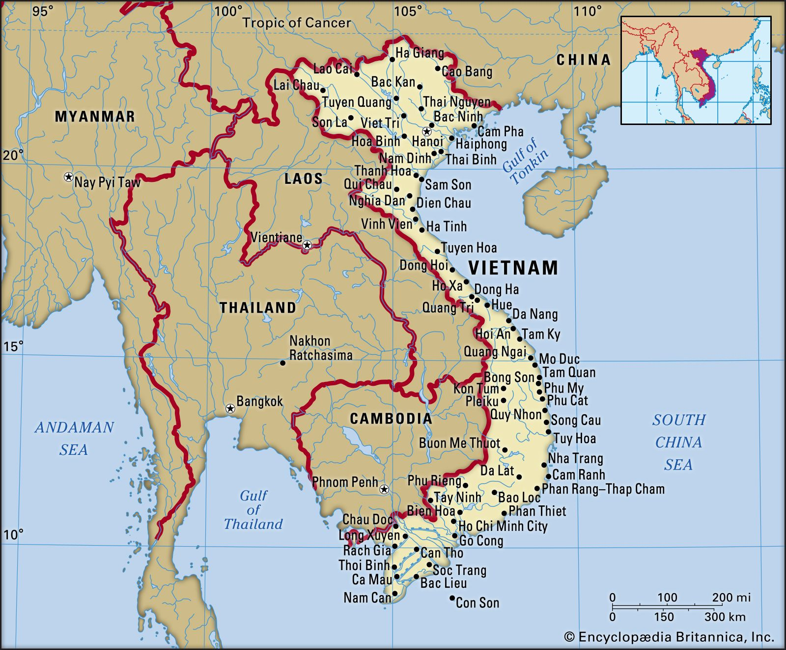

Figure Map of Vietnam

1. **Demographic Profile:**

As of 2019, Vietnam has a population of almost 96.5 million. Among which the Urban population makes up about 35 percent (33.8 million) while the rural population accounts for 65 percent (62.7 million) of the overall population.

Around 49.8 percent (48 million people) are male, while 50.2 percent (48.5 people) are female.

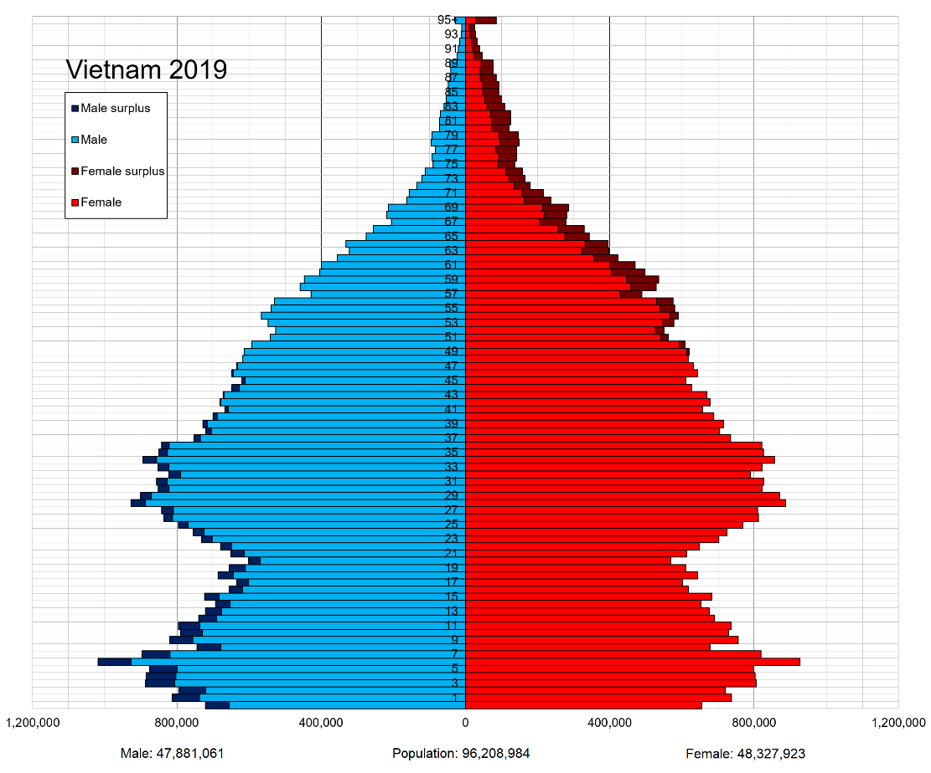

Figure Pictorial Representation of Vietnamese Demographic Profile

1. 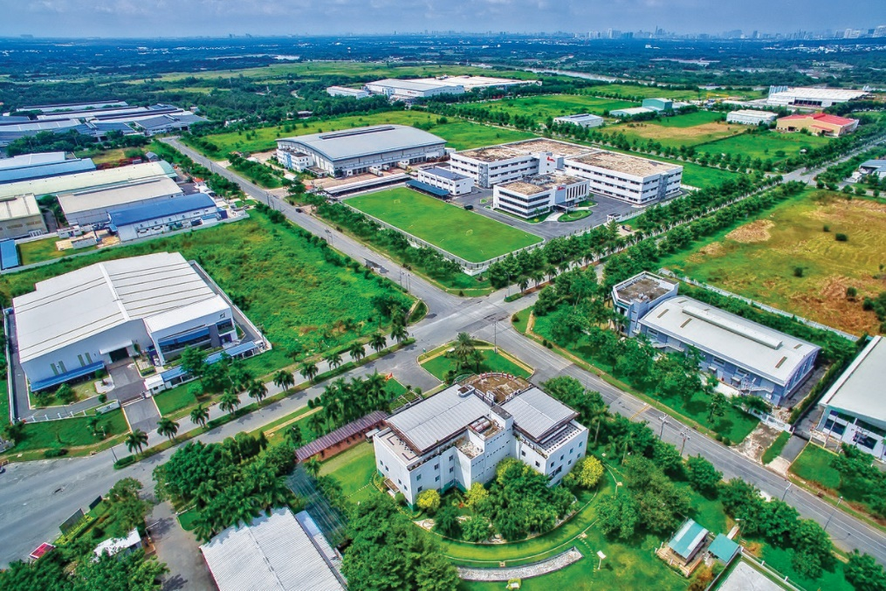**Industrial Profile:**

Figure Picture of an industrial zone in Vietnam

Following are some of the key industries of Vietnam:

1. Infrastructure
2. Manufacturing
3. Retail
4. Food
5. Agriculture

Prominent manufacturing sectors in Vietnam include textile, garments, furniture and electronics etc. These industries are located in Southeast Vietnam and the Red River Delta in the Northeast.

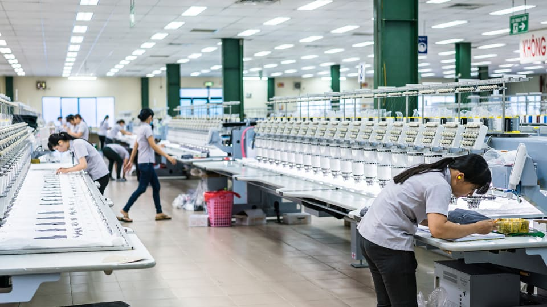Hanoi and Ho Chi Minh City have been important industrial centers, other provinces such as Binh Duong, Dong Nai, Hai Phong and Bac Ninh are also seeing an increased MNC presence. Renowned international firms such as Samsung Electronics, Intel and Siemens have also set up factories in the country.

Figure Workers in an Electronics Factory

1. **Consumer Market:**

Asia is world’s consumption growth engine, [according to recent McKinsey Global Institute research](https://www.mckinsey.com/featured-insights/asia-pacific/beyond-income-redrawing-asias-consumer-map) Asia offers a $10 trillion consumption growth opportunity over the next decade.

Vietnam is well positioned be a significant driver of the upcoming chapter in Asia’s consumption story. Its is estimated that over the next decade, around 36 million consumers will join Vietnam’s consuming class (defined as consumers who spend minimum $11 a day in terms of PPP(purchase power parity)).

Vietnam has shown significant growth in the recent years, in the 2000 less than 10% of Vietnam’s total population were members of the consumer class, by 2030 this number is predicted to rise near 75 percent of the overall population.

The highest tier of consuming class (those spending $30 per day) is growing at a rapid rate and may constitute 20% of Vietnam’s total Population.

# **Description of Company**

1. **Introduction:**

Peugeot Automobile started out as an Industrial manufacturer back in 1810, a steel factory making band saws and umbrella frames. It wasn’t until the 1889 that Peugeot started manufacturing cars, making Peugeot world’s second oldest car manufacturer and one of the oldest continuous car brands.

Figure 5 Peugeot's Logo

Since 1850 Peugeot has used the Lion’s symbol to represent itself. Originally appearing on the company’s saw blades, the Lion symbolized the toughness of the saw’s teeth, the flexibility of blade like the lion’s spine, the strength of the steel and the speed of the cut, like a bounding lion.

1. **A brief History**

**“A Symbol of Strength and Sharpness”**

Jean-Pierre PEUGEOT, was born in 1934 is known as the founder of Peugeot. Peugeot incorporated the **LION SYMBOL** in its marketing to represent the strength and sharpness of its products, symbolized through the lion’s jagged and sharp teeth. The logo was registered as their trademark in 1858.

Peugeot unveiled its first car in 1889, but it wasn’t until 1929 till Peugeot started making its name in the automobile industry. Peugeot’s first mass produced car the **“-201”** was the first car to use the now-iconic three digit numbering system with a zero in the middle.

Peugeot stated making strides in the automotive industry with the launch of this 80cc SC/SX scooter known as the S55. Peugeot’s popularity skyrocketed with the launch of its infamous coupe-cabriolet which gave birth to a whole new class of enthusiast vehicles.

Over the years Peugeot didn’t limit itself only to 4 wheel vehicles manufacturing, they diversified and started making bicycles that went on to win Tour de France (World’s biggest cycling competition). During the course of 20th Century Peugeot kept making steady advancements in the automobile industry. Peugeot went on to acquire one of its biggest competitors **Citroen** in 1974. Three year later in 1977, Peugeot won its 10th Tour de France race making it the longest record number of victories in the said competition.

In 2009 the brand made motorsport history by coming in on the first and second places in the tough endurance race, Le Mans 24-hour. PEUGEOT Sport continued to make history in the world of motorsports, but is also committed to other areas of sporting achievement.  
  
This includes sponsoring the French Open for 14 years, being official partner of the Lancôme Trophy until 2003, and even launching its own golf tournament, the PEUGEOT RCZ Cup.

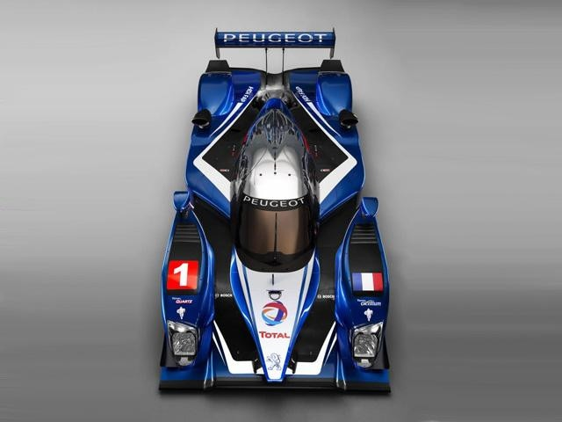

Figure 6 Peugeot 2009 speed car

# **Recommendation of Entry Strategy**

1. **Introduction:**

In today’s globalized macroeconomic world, automotive sectors remains as one of the most promising sectors with projections of double digits growth. Asia’s emerging economies such as Vietnam serve as compelling choices for automotive players looking for diversification.

Vietnam’s automobile industry has seen significant growth in recent years due to the country’s fast growing middle class. The average growth in the Vietnamese automotive sector during the period of 2015-2020 has been 10 percent per year.

Vietnam’s Industrial Policy and Strategy Institute predicts 750,000 to 800,000 vehicles will be sold annually by 2025 up from 288,683 in 2018. The automotive industry also serves as a major contributor to the GDP of Vietnam.

1. **Recommendations:**

Assessing the current state of Vietnamese automotive sector, the preferable mode of entry for a new automotive maker like Peugeot Automotives will be a joint venture with a local automotive manufacturer.

A joint venture in accordance with the current policies of the Vietnamese Govt. will help Peugeot in the following sectors:

1. The Automotive industry of Vietnam suffers from lack of localization. Overall, Vietnam has significant less localization rate than its neighboring countries. The Govt is pushing Auto manufacturers to put emphasis on localization.
2. In two years (till 2024) the tariff on complete-built-in (CBU) units on automobiles imported from other ASEAN countries will be increased, thus currently it is the perfect time for the new market entrant to start developing it local manufacturing capabilities which will pay off in the long run when the tariff of CBU units will be increased.

Vietnam Electric commercial vehicle market also projects double digit growth in the current and the next decade owing to the country’s increased need for fuel-efficient and emission free vehicles and growing demand for electric commercial vehicles.

The company is also advised to invest in electric vehicles infrastructure which would serve as an important diversification venue as Electric vehicles become more mainstream and battery charging tech advances.

# 

# **Segmentation, Targeting, and Formulation of Marketing Mix:**

1. **Segmentation:**

In 2020 103,746 vehicles were sold in Vietnam. A 8 percent increase compared to the previous year, According to the Vietnam Automobile Manufacturers Association. Segment wise, passenger, commercial, and special-use vehicles comprised of 65 percent, 25 percent and 10 percent respectively. Domestically assembles cars accounted for the majority at 87,426. However, the sales of imported cars also increased by 3 percent.

1. **Targeting:**

Passenger cars are one of the most sold vehicles in Vietnam according to recent trends. The Revenue of the passenger cars market is projected to reach US $6.33bn in 2022. Passenger Cars market sales are expected to reach 204.72k vehicles in 2026.

The market’s largest segment is Large SUV with projected market volume of US $1.3bn in 2022. Launching cars in the SUV and sedan segments would be a good starting point since these segments have the biggest market share in the Vietnamese automobile market. Peugeot 2008,3008 and 5008 are ideal candidates.

1. **Marketing Mix:**

The marketing mix of Peugeot will be based on four Ps of marketing which are:

1. Product
2. Price
3. Place
4. Promotion
5. **Product:**

Peugeot cars are known for their strength and reliability. The marketing campaigns should highlight the safety standards and relevant licenses of Peugeot cars to position itself as a reliable option for safe and high quality cars in the market.

1. **Price:**

The price of Peugeot cars will have to be market competitive since the brand will face competition from established auto manufacturers like KIA, Toyota and Honda.

1. **Place:**

Most of the Urban Population of Vietnam lives around the north of the country. The brand should target northern Vietnam since it has a higher concentration of middle class people and a relatively high per capita income, such people will serve as the ideal target customers for Peugeot.

1. **Promotion:**

The brand should incorporate digital platforms in its marketing strategies as well such as Youtube, Tiktok and Facebook Ads along with conventional avenues of marketing.

**THE END**

**References:**

1. About Vietnam. (n.d.). *Socialist Republic of Viet Nam Government Portal.* Retrieved December 10, 2020, from [http://chinhphu.vn](http://chinhphu.vn/portal/page/portal/English/TheSocialistRepublicOfVietnam/AboutVietnam/AboutVietnamDetail?categoryId=10000103&articleId=10000505) [↩](https://www.eyeonasia.gov.sg/asean-countries/know/overview-of-asean-countries/vietnam-a-country-profile/#fnref:1) [↩2](https://www.eyeonasia.gov.sg/asean-countries/know/overview-of-asean-countries/vietnam-a-country-profile/#fnref:1:1) [↩3](https://www.eyeonasia.gov.sg/asean-countries/know/overview-of-asean-countries/vietnam-a-country-profile/#fnref:1:2)
2. Statistical yearbook of Viet Nam 2019. (2020). *General Statistics Office,* p. 97. Retrieved December 10, 2020, from [https://www.gso.gov.vn](https://www.gso.gov.vn/wp-content/uploads/2020/09/Nien-giam-thong-ke-day-du-2019.pdf) [↩](https://www.eyeonasia.gov.sg/asean-countries/know/overview-of-asean-countries/vietnam-a-country-profile/#fnref:2) [↩2](https://www.eyeonasia.gov.sg/asean-countries/know/overview-of-asean-countries/vietnam-a-country-profile/#fnref:2:1)
3. Nguyen Xuan Phuc was sworn in as Prime Minister. (2016, April 7). *Vietnam Government Portal*. Retrieved December 10, 2020, from [http://primeminister.chinhphu.vn](http://primeminister.chinhphu.vn/VideoView.aspx?itemid=38) [↩](https://www.eyeonasia.gov.sg/asean-countries/know/overview-of-asean-countries/vietnam-a-country-profile/#fnref:3)
4. Vietnam culture overview. (n.d.). *Socialist Republic Viet Nam Government Portal.* Retrieved December 10, 2020, from [http://chinhphu.vn](http://chinhphu.vn/portal/page/portal/English/TheSocialistRepublicOfVietnam/AboutVietnam/AboutVietnamDetail?categoryId=10000103&articleId=10000475) [↩](https://www.eyeonasia.gov.sg/asean-countries/know/overview-of-asean-countries/vietnam-a-country-profile/#fnref:4)
5. Monetary policy objectives. (n.d.). *The State Bank of Vietnam.* Retrieved December 10, 2020, from [https://www.sbv.gov.vn](https://www.sbv.gov.vn/webcenter/portal/en/home/sbv/mpolicy/mpobjectives?_afrLoop=9493476159015297#%40%3F_afrLoop%3D9493476159015297%26centerWidth%3D80%2525%26leftWidth%3D20%2525%26rightWidth%3D0%2525%26showFooter%3Dfalse%26showHeader%3Dfalse%26_adf.ctrl-state%3Ddun3q655m_108) [↩](https://www.eyeonasia.gov.sg/asean-countries/know/overview-of-asean-countries/vietnam-a-country-profile/#fnref:5)
6. Statistical yearbook of Viet Nam 2019. (2020). *General Statistics Office,* p.191. Retrieved December 10, 2020, from [https://www.gso.gov.vn](https://www.gso.gov.vn/wp-content/uploads/2020/09/Nien-giam-thong-ke-day-du-2019.pdf) [↩](https://www.eyeonasia.gov.sg/asean-countries/know/overview-of-asean-countries/vietnam-a-country-profile/#fnref:6) [↩2](https://www.eyeonasia.gov.sg/asean-countries/know/overview-of-asean-countries/vietnam-a-country-profile/#fnref:6:1)
7. Overview on Vietnam geography. (n.d.). *Socialist Republic Viet Nam Governmental Portal.* Retrieved December 10, 2020, from [http://chinhphu.vn](http://chinhphu.vn/portal/page/portal/English/TheSocialistRepublicOfVietnam/AboutVietnam/AboutVietnamDetail?categoryId=10000103&articleId=10000505) [↩](https://www.eyeonasia.gov.sg/asean-countries/know/overview-of-asean-countries/vietnam-a-country-profile/#fnref:7)
8. Statistical yearbook of Viet Nam 2019. (2020). *General Statistics Office,* p.93. Retrieved December 10, 2020, from [https://www.gso.gov.vn](https://www.gso.gov.vn/wp-content/uploads/2020/09/Nien-giam-thong-ke-day-du-2019.pdf) [↩](https://www.eyeonasia.gov.sg/asean-countries/know/overview-of-asean-countries/vietnam-a-country-profile/#fnref:8)
9. Statistical yearbook of Viet Nam 2019. (2020). *General Statistics Office,* p.97-98. Retrieved December 10, 2020, from [https://www.gso.gov.vn](https://www.gso.gov.vn/wp-content/uploads/2020/09/Nien-giam-thong-ke-day-du-2019.pdf) [↩](https://www.eyeonasia.gov.sg/asean-countries/know/overview-of-asean-countries/vietnam-a-country-profile/#fnref:9)
10. Ethnic groups in Vietnam. (n.d.). *Socialist Republic of Viet Nam Government Portal.* Retrieved December 10, 2020, from [http://chinhphu.vn](http://chinhphu.vn/portal/page/portal/English/TheSocialistRepublicOfVietnam/AboutVietnam/AboutVietnamDetail?categoryId=10000103&articleId=10002652) [↩](https://www.eyeonasia.gov.sg/asean-countries/know/overview-of-asean-countries/vietnam-a-country-profile/#fnref:10)
11. Statistical yearbook of Viet Nam 2019. (2020). *General Statistics Office,* p. 26. Retrieved December 10, 2020, from[https://www.gso.gov.vn](https://www.gso.gov.vn/wp-content/uploads/2020/09/Nien-giam-thong-ke-day-du-2019.pdf) [↩](https://www.eyeonasia.gov.sg/asean-countries/know/overview-of-asean-countries/vietnam-a-country-profile/#fnref:11)
12. Profiled industries. (2019, December 2). *Enterprise Singapore.* Retrieved December 10, 2020, from [https://www.enterprisesg.gov.sg](https://www.enterprisesg.gov.sg/overseas-markets/asia-pacific/vietnam/profiled-industries) [↩](https://www.eyeonasia.gov.sg/asean-countries/know/overview-of-asean-countries/vietnam-a-country-profile/#fnref:12) [↩2](https://www.eyeonasia.gov.sg/asean-countries/know/overview-of-asean-countries/vietnam-a-country-profile/#fnref:12:1) [↩3](https://www.eyeonasia.gov.sg/asean-countries/know/overview-of-asean-countries/vietnam-a-country-profile/#fnref:12:2)
13. Statistical yearbook of Viet Nam 2019. (2020). *General Statistics Office,* p. 29. Retrieved December 10, 2020, from [https://www.gso.gov.vn](https://www.gso.gov.vn/wp-content/uploads/2020/09/Nien-giam-thong-ke-day-du-2019.pdf) ; Tourism contributes significantly to Vietnam’s economy. (2016, July 11). *VietnamNet*. Retrieved December 10, 2020, from [http://english.vietnamnet.vn](http://english.vietnamnet.vn/fms/business/161915/tourism-contributes-significantly-to-vietnam-s-economy.html) [↩](https://www.eyeonasia.gov.sg/asean-countries/know/overview-of-asean-countries/vietnam-a-country-profile/#fnref:13)
14. A beginners guide to Viet Nam now. (2019). *Vietnam National Administration of Tourism.* Retrieved December 10, 2020, from [https://vietnam.travel](https://vietnam.travel/sites/default/files/2019-11/Beginner%27s%20Guide%20to%20Vietnam%20Now.pdf) [↩](https://www.eyeonasia.gov.sg/asean-countries/know/overview-of-asean-countries/vietnam-a-country-profile/#fnref:14)
15. Statistical yearbook of Viet Nam 2019. (2020). *General Statistics Office,* p. 606. Retrieved December 10, 2020, from [https://www.gso.gov.vn](https://www.gso.gov.vn/wp-content/uploads/2020/09/Nien-giam-thong-ke-day-du-2019.pdf) [↩](https://www.eyeonasia.gov.sg/asean-countries/know/overview-of-asean-countries/vietnam-a-country-profile/#fnref:15)